Assignment 2 (Week 2)
- Download BOM for SM32L475 Kit, find all sensors and modules for slide 6, download their data sheets, read it and decide what bus it uses and how many signal (control) lines need to be connected to the uC. For example, for U3 it will be I2C bus and IRQ line – total 3 signal lines, and so on. Show buses for sensors and for RF Modules on your Block Diagram.
  - For sensors:
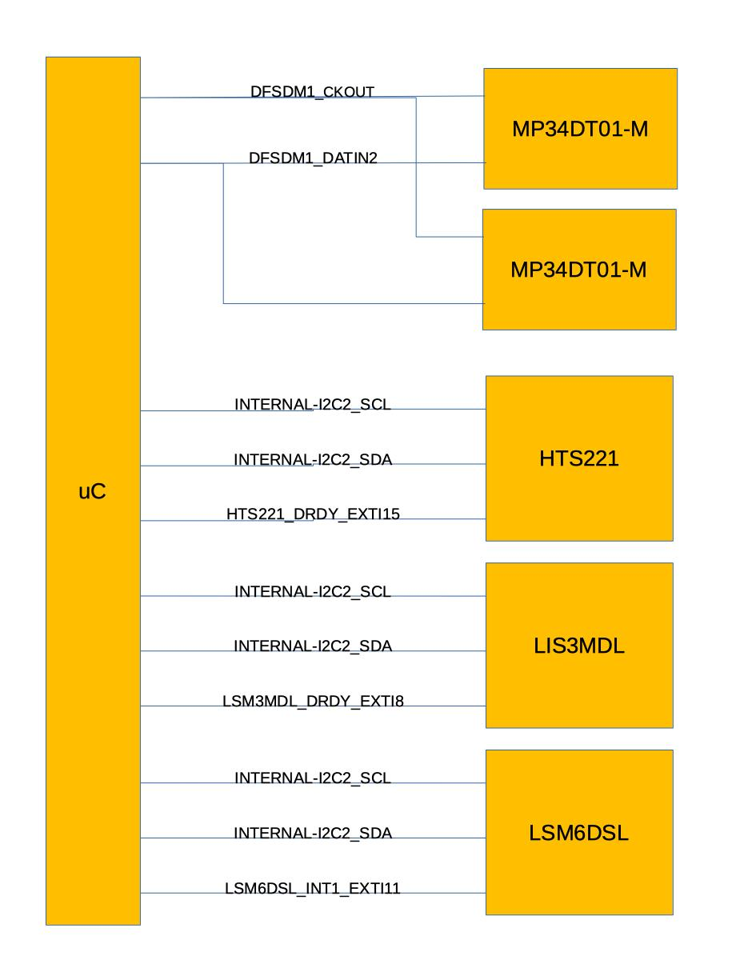
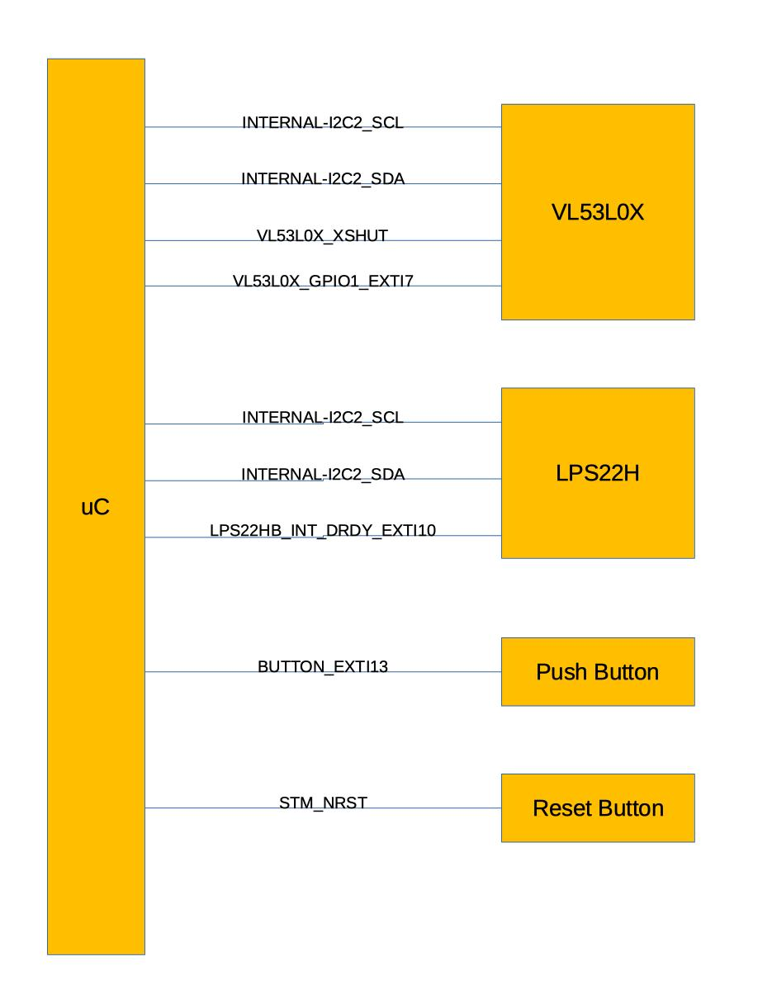
    - Two on-board ST-MEMS microphones (MP34DT01) need CLK line and Dout line, total 2 lines.
    - Capacitive digital sensor for relative humidity and temperature (HTS221) sensor needs two I2C lines and 1 IRQ line, total 3 lines
    - High-performance 3-axis magnetometer (LIS3MDL) needs two I2C lines and 1 IRQ line, total 3 lines
    - 3D accelerometer and 3D gyroscope (LSM6DSL) needs two I2C lines and 1 IRQ line, total 3 lines
    - 260-1260 hPa absolute digital output barometer (LPS22HB) needs two I2C lines and 1 IRQ line, total 3 lines
    - Time-of-Flight and gesture detection sensor (VL53L0X) needs two I2C lines, 1 IRQ line, and 1 Xshutdown (Reset) line, total 4 lines
    - Push button needs 1 IRQ line
    - Reset button needs 1 NRST line
  - For RF modules:
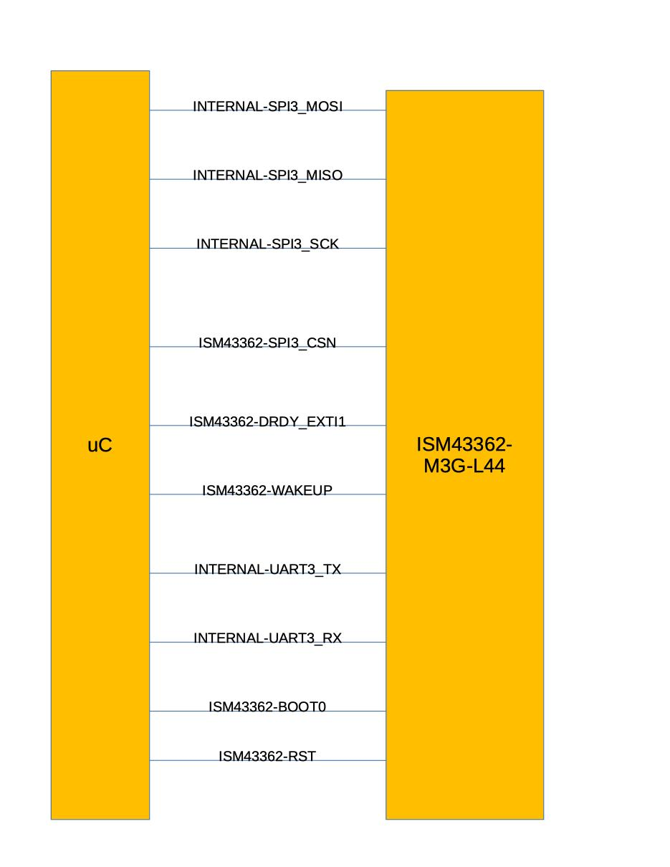
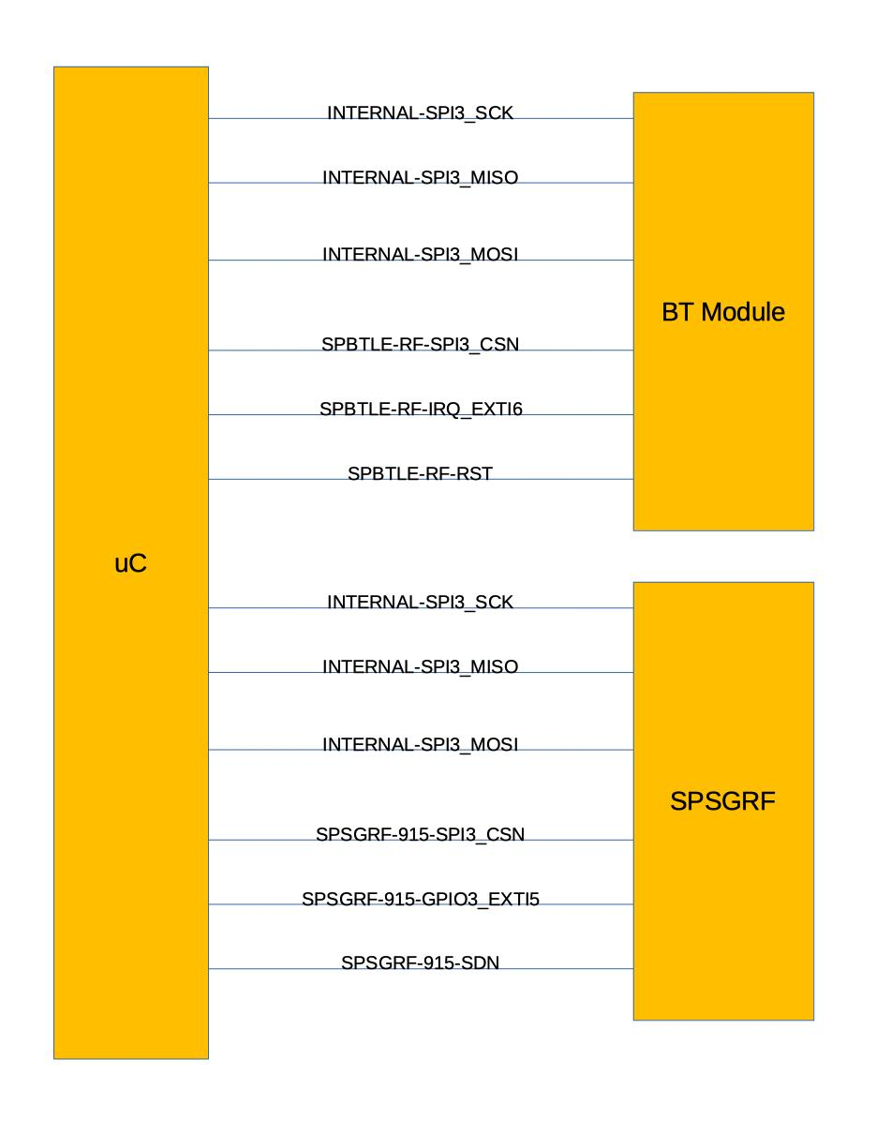
- Bluetooth (V4.1 compliant) SPBTLE-RF module needs 4 SPI lines, 1 reset line, and 1 IRQ line, total 6 lines
- Sub-GHz low-power-programmable RF module (SPSGRF-868 or SPSGRF-915) needs 4 SPI lines, 1 SDN pin, and 1 IRQ line, total 6 lines
- Wi-Fi module Inventek system ISM43362-M3G-L44 (802.11 b/g/n) needs 4 SPI lines, 2 UART lines, 1 IRQ line, I wakeup line, 1 BOOT line, and 1 RST line, total 10 lines.
(Note: From the above block diagram, I did not include the common GND and 3.3V)

